11th INTERNATIONAL ALUMINIUM SYMPOSIUM

FORMATTING AND WORD TEMPLATE

Hüseyin Savaş¹, Erol Metin²

¹METEM UCTEA Chamber of Metallurgical and Materials Engineers Training Center, Türkiye
²TALSAD Turkish Aluminium Industrialists Association, Türkiye

Keywords: Aluminium, Iron, Steel, Refractory, Metals, Energy

Abstract

The manuscript body should contain abstract, introduction, experimental studies, results and conclusion parts after the set of title, author name(s), affiliation(s) and keywords. Further parts (and subheadings) are under the initiative of author(s) in accordance with the content integrity. The manuscript is in two column formatting after the keyword line.

1. Introduction

The top of the first page of your paper begins with the title of your paper. The title must be 14 pt., bold, centered and in all caps. It is just allowed to use lower-case letters for element abbreviations etc.

Author name(s), affiliation(s) and a list of keywords must be followed the title respectively, and they should be 10 pt. and centered. If there is more than one author, the author names are on the same line. Superscript numbers are used for the authors from different affiliations. Each author affiliation should be put on a separate line with a superscript number at the beginning of the related affiliation. Please use at least three keywords. Leave a blank line between title, author name(s), affiliation(s) and keywords, and before beginning the rest of the paper.

The typeface of the manuscript should be Times New Roman, 10 pt. and justified. The manuscript must be written in English. The manuscript has to consist of minimum 4 pages and maximum 8 pages.

2. Experimental Procedure

All equations and reactions should be typed flush left and numbered in parentheses at the right-hand margin. Equations separated from the text by one blank line of space above and below.

Ca(CO)₃ → CaO + CO₂ (1)

First-level subheadings are flush left, bold and numbered (without Abstract, References and Acknowledgment - if desired) and first letter of each word capitalized. All headings should be separated from the text by one blank line of space above and below.

2.1. Second-level subheading

Second-level subheadings are flush left, bold, numbered (such as 1.2., 1.3.) and first letter of each heading capitalized.

Third-level subheading

Third-level subheadings are flush left, underlined and first letter of each heading capitalized.

3. Results and Discussion

Tables and table titles should be prepared in the form given below. A 10 pt. font size is preferred in tables. However, 8 and 9 pt. font sizes are acceptable to fit the data in tables, if necessary.

Table 1. Quantitative analysis result of sample.
Fe | Si | Cu | Mn | Mg
1.02 | 7.54 | 3.45 | 0.36 | 0.32

Figures and figure titles should be prepared in the form given below. Figures should be in a readable quality.

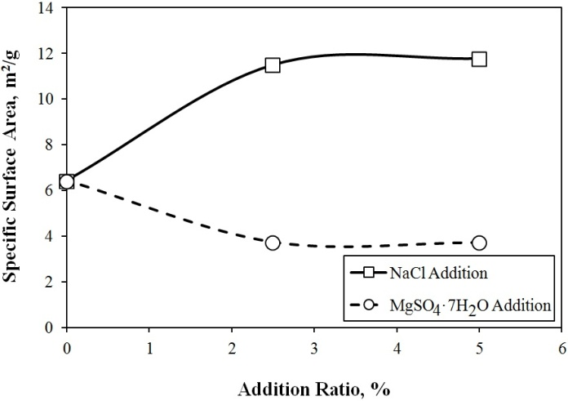
Figure 4. Specific surface area results of samples.

4. Conclusion

Please do not add page numbers, because they are going to be added at the time of publishing. Color is acceptable in the manuscript, but if the publication will be in a print volume, all material is going to publish in black and white. Thus, it will be better to prefer black and white colors particularly in figures. SI units must be used in the manuscript. Page size is 215.9 mm x 279.4 mm. Top and bottom margins are 25 mm. Please use 20 mm margin both for left and right side.

Acknowledgment

If it is desired, an acknowledgment part can be added to the manuscript. References should be given in the references part with the order where it is used in the text body. Typing formats of references are shared in the references section below. [1] corresponds to journal articles, [2] for conferences proceedings and abstracts, [3] for books, [4] for chapters in the books, [5] for theses and [6] for websites. For different type of references, please use the closest format.

References

[1] U. Demircan, B. Derin and O. Yücel, Materials Research Bulletin, 42 (2007) 312-318.
[2] A. Turan, F. C. Sahin, G. Goller and O. Yucel, Spark Plasma Sintering of TiB₂ Ceramics, 13th Conference of the European Ceramic Society (ECerS XIII), 23-27 June 2013, Limoges, France.
[3] W. G. Davenport, M. King, M. Schlesinger and A. K. Biswas, Extractive Metallurgy of Copper, Pergamon, 2002, Oxford, United Kingdom.
[4] D. Sherman, D. Brandon, Mechanical Properties and their Relation to Microstructure, Ed. by R. Riedel, Handbook of Ceramic Hard Materials, Wiley-VCH, 2000, Weinheim, Germany.
[5] M. Buğdaycı, Krom Nikel İçeren Demirli Alaşımların Metalotermik Yöntemle Üretiminde Tufal Kullanımının Etkisi, M.Sc. Thesis, Istanbul Technical University, 2014, İstanbul, Turkey.
[6] <http://www.metal-powder.net> Dated: 11.12.2015.

